Ex no: 14

Date:

**SIMPLE PROGRAMMING EXERCISE USING (CASE & LOOP)**

**AIM:** To write a function that uses case command and loop command.

1. **To create a function get_income_level:**

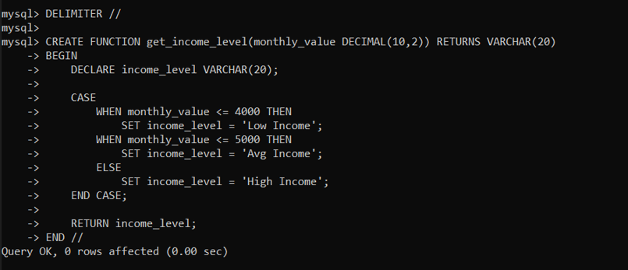

1. **To use given commands:**

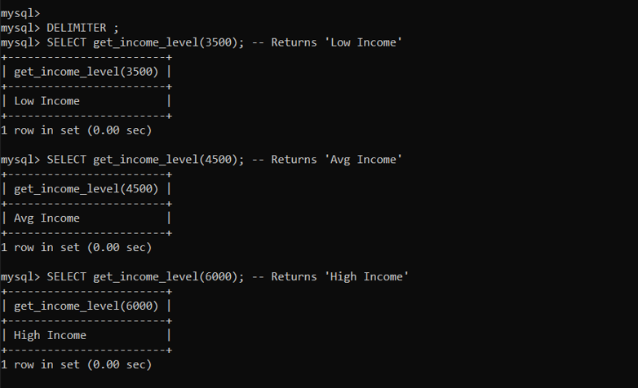

**Result:**

Case and loop commands are successfully executed.